**SECOND TERM E-LEARNING NOTE**

**SUBJECT:TECHNICAL DRAWING**

**CLASS:SS1**

**TITLE:SECOND TERM SCHEME OF WORK**

**WEEK 1:** Revision of the work for last term. Inscribed and circumscribed.

**WEEK 2** Escribed circle.

**WEEK 3:**Polygons

**WEEK 4:** Plain scales

**WEEK 5:** Diagonal and chordalScales

**WEEK 6:**  Enlargement and reduction of plain figures

**WEEK 7:** Enlargement and reduction of plain figures

**WEEK 8:** Equal area of figures

**WEEK 9:** Equal area of figures

**WEEK 10:** Tangency

**WEEK 11**.Revision and Examination.

***Reference materials:***

Technical drawing by J.N. Green.

Engineering drawing 1 by M.A.Parker and F.Pickup

Metal work technology by G.H. Thomas.

Drafting Technology and practice by William P. Spence

Technical Drawing by F.B Mayock( 1- 4 )

Basic technology for junior secondary schools book 1 by G.N Nneji, E.J. Okon, V.C. Nwachukwu, N.A. David, and T.C. Ogbuanya.Pages 1-17, 34-78.

Basic technology for junior secondary schools book 2 by I. Elekwa , O.A. Bamiro, A.O. Oluyide,

D.L Ladoye, A. Nurudeen and I.O. Akuru

Technical drawing for senior secondary schools by Y.A Thanni and C.A Faseun-Motesho Pages 97-103

**WEEK ONE DATE:………………**

**Revision of last term work. Inscribed and circumscribed circles**

**Content:**

(i) Inscribed circles.

(ii) Circumscribed circles

**Inscribed circles**

**Example 1 *To inscribe a circle in a given triangle.***

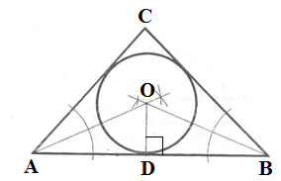

**Method:**

Draw the given triangle ABC.

Bisect any two angles whose bisectors intersect at point O.

Draw a line from point O perpendicular to any side of the triangle ie OD.

With the compass pin at point O and radius OD, draw the required circle.

**Example 1 *To inscribe threeequal circles in an equilateral triangle, each circle to touch two sides and***

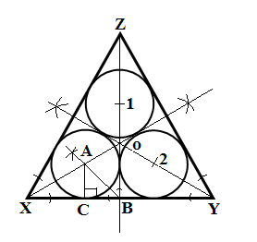

***two other circles***

**Method:**

(i) Draw the given equilateral triangle.

(ii) Bisect any two of the angles e.g X and Y to obtain the centre of the triangle, O.

(iii) Draw a line from Z through O to B.

(iv) Bisect angle OBC to obtain the centre of one of the circles, A.

(v) With O as centre and radius OA, locate the centres 1 and 2 of the remaining two circles.

(vi) Drop a perpendicular from A which meets line XB at point C. AC is the radius of the three circles.

(vii) With compass pin at points A, 1 and 2 in turn, draw the three circles.

**Example 3*To inscribe a circle in any sector.***

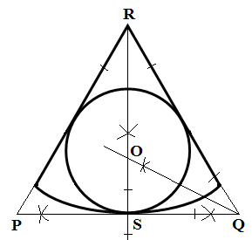

**Method:**

(i) Bisect the vertical angle R. This angular bisector meets the arc of the sector at point S.

(ii) Construct a tangent at point S.

(iii)Extend the radius of the sector to meet the tangent at points P and Q.

(iv)Bisect one of the base angles e.g< RQS to obtain the centre of the circle, O.

(v) With O as centre and radius OS, draw the required circle.

**Example 4*To inscribe a circle in any regular polygon, rhombus or deltoid(kite).***

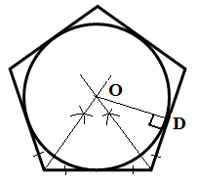

Method:

(i) Bisect any two angles of the given polygon. The two bisectors meet at a point O.

(ii) Point O is the centre of the circle. Drop a perpendicular from O to any side of the polygon, ie OD.

(iii)With O as centre and radius OD, draw the required circle.

**Evaluation Questions**

1. A triangle ABC stands on side AB as base and has the following dimensions: AB = 60mm, AC = 50mm

and angle CAB = 670. Construct the triangle and draw a circle in it.

2. Construct a regular polygon whose side is of length 40mm. Draw a circle in it to touch all the sides.

**Circumcribedcircles**

**Example 1 *To circumscribe a circle on a triangle or inscribe a triangle in a circle***

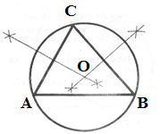

**Method:**

(i) Draw the given triangle ABC.

(ii) Bisect any two sides of the triangle ie AC and BC, These bisectors intersect at point O.

(iii) With O as centre and radius OA or OB or OC, draw a circle to pass through the three points.

**Evaluation Questions**

1. Construct a triangle ABC on AB as base with AB = 70mm, AC = 57mm and BC = 76mm. Circumscribe a

circle on it.

2. Construct a triangle ABC with side AB = 70mm, AC = 90mm and < ABC = 1050. Circumscribe a circle

on it.

**General evaluation/revisionalquestions**

1. A triangle has a perimeter 130mm, base 40mm and a base angle 1050. (i) Construct the triangle.

(ii) Measure and state the other base angle. (WAEC)

2. Construct a triangle PQR with base = 70mm, vertical height = 50mm and vertical angle = 550

(WAEC)

3. Construct a triangle whose perimeter is 120mm and of sides in the ratio 3:4:5. (WAEC).

4. Construct a triangle of sides AB = 60mm, AC = 55mm and < ABC = 600. Construct a triangle similar

to this and whose perimeter is 140mm.

5. Inscribe an octagon in a square of side 80mm.

**Reading assignment**

Technical drawing by JN Green.Pages 20-22.

**Weekend Assignment**

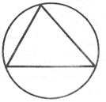

**Objective**

1. Which of the following best describe the figure shown above? A. Inscribed. B. Circumscribed.

C. Escribed. D. Rebated.

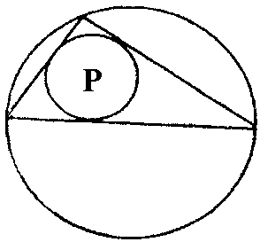

2. The circle P in the figure above can best be described as A. inscribed. B. circumscribed. C. escribed.

D. concentric.

3. Which of the following is correct in inscribing a circle in a triangle? A. Bisect one of the angles.

B. Bisect two sides of the triangle. C. Bisect two angles. D. Bisect three sides.

4. In order to circumscribe a circle on a triangle, which of the following is a correct step? A. Bisect two

sides of the triangle. B. Bisect two angles of the triangle. C. Bisect one side and angle. D. Bisect two

angles and one side.

5. Which of the following represents the radius of the circle drawn below? A. QR. B. OT. C. OP.

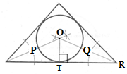

D. OQ

**Theory**

1. Construct a triangle PQR with side PQ = 80, and angle PQR = QPR = 600. (show all construction lines).

(i) Find the lengths PR and QR. (ii) Inscribe a circle in the triangle PQR. (iii) Name the triangle PQR.

2. Construct a triangle ABC with side AB = 50mm, AC = 90mm and < ABC = 1050. Circumscribe a circle

on the triangle.

**WEEK TWO DATE:………………**

**Escribed circles**

**Content:**

(i) Escribed circles.

(ii) Drawing of circles to touch some given points.

**Escribed circles.**

**Example 1 *To escribe a circle on a given triangle.***

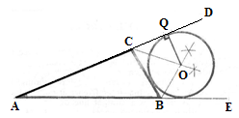

**Method:**

(i) Draw the given triangle ABC.

(ii) Extend AC to D and AB to E.

(iii) Bisect the two exterior angles <DCB and <EBC

whose bisectors intersect at point O.

(vi) Draw a line from O perpendicular to any of the sides.

(v) With O as centre and radius OQ, escribe the circle.

**Example 2 *To escribecircles on a given polygon.***

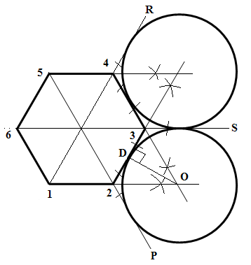

**Method:**

(i) Draw the given polygon and join opposite corners as shown above.

(ii) Bisect external angles P23 and S32 whose bisectors meet at point O, the centre of the circle.

(iii)Drop a perpendicular, OD to side 2-3. This is the radius of the circle.

(iv)With O as centre and radius OD, draw a circle. Repeat the above procedure for each side and circle.

**Evaluation Questions**

1. Escribe a circle on a triangle of sides AB = 55mm, AC = 60mm and BC = 50mm.

2 . A regular hexagon has its sides 50mm long. Draw the hexagon and describe circles about it.

**Drawing of circles to pass through given points.**

**Example 1*To draw a circle to pass through a given point and touch a line at a given point***

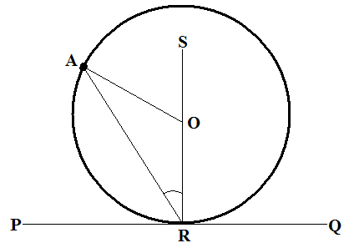

**Method:**

(i) Locate the given point A and the given point R on the given line PQ.

(ii) Join the two given points ie, RA.

(iii)Erect a perpendicular at the point R on the given line.

(iv) Draw a line AO from point **A** to meet the perpendicular RS at point O; such that angle RAO is equal to

angle ORA. Point O is the centre of the circle that will pass through the given points.

**Example 2*To draw a circle to pass through two given points and touch a given line.***

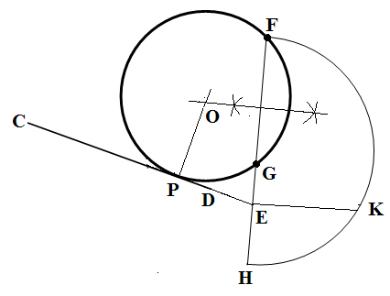

**Method:**

(i) Locate the two given points F and G and draw the

given line CD.

(ii) Draw a line to connect F and G and extend the line.

(iii) Extend the line CD to meet FG extended at point E.

(iv) Mark off EH equal to EG.

(v) Construct a semicircle on line FH.

(vi) Draw a line perpendicular to AH at point E to touch the semicircle at point K.

(vii) Mark off EP equal to EK.

(viii) Draw a line perpendicular to CD at point P and this line intersects the

bisector of FG at point O, thecentre of the circle required.

(ix) With O as centre and radius OP, draw the circle.

**Evaluation Questions**

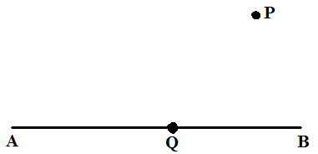

1. Draw a line AB of length 80mm and locate a point Q on it which is 20mm from end B. Draw a circle to

touch points P which is at a suitably chosen distance and Q.

2. Draw a circle to pass through points P and B and also touch line AC as shown below. Choose suitable

positions for points P and B and line AC.

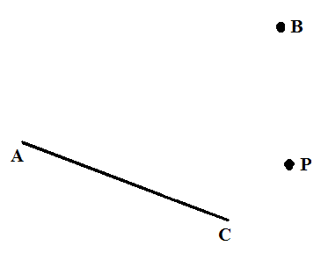

**General evaluation/ revisional questions**

1. Draw an equilateral triangle of side 60mm and inscribe three equal circles with two circles touching each side.
2. Choose any convenient point S and draw a tangent to the circle shown below.

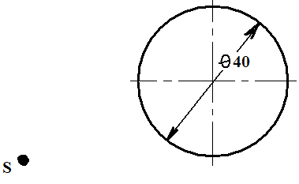

3. Determine graphically the circumference of a circle, diameter 35mm.

4. Construct a line of approximate length to the given arc shown below.

**Reading assignment**

Technical drawing by JN Green. Pages 21, 73-75.

**Weekend Assignment**

**Objective**

1. Which of the following is correct in escribing a circle on a triangle? A. Bisect two internal angles.

B. Bisect two sides of the triangle. C. Bisect two external angles. D. Bisect three sides of the triangle.



2. The radius of the circle drawn in the diagram above is represented by line A. CD. B. OB. C. OQ.

D. QD.

3. The figure below shows the construction of a/an A. circumscribed circle. B. circumscribed triangle.

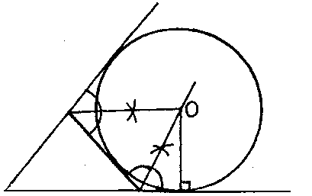

C. escribed triangle. D. escribed circle.

4. Which of the following is not a procedure for describing a circle round a polygon? A. Bisect two external

angles. B. Bisect two sides. C. Draw a line from the determined centre, parallel to one side.

D. Draw a line from the determined centre, perpendicular to one side.

5.AB is the diameter of the circle shown below. What type of triangle is ABC? A. Scalene. B. Right

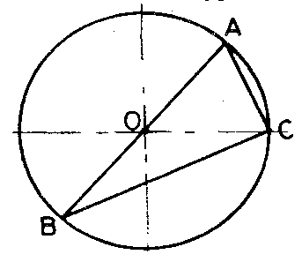

angled. C. Oblique. D. Isosceles.

**Theory**

1 . A regular hexagon has its sides 50mm long. Draw the hexagon and describe circles about it.



2. Draw a line AB of length 80mm and locate a point Q on it which is 20mm from end B. Draw a circle to

touch points P which is at a suitably chosen distance and Q.

**WEEK THREE DATE:………………**

**Topic:Polygons and irregular figures**

**Content:**

(i) Meaning and types of polygon.

(ii) Construction of polygons.

**Meaning and types of polygon**

Polygons could be defined as plane figures whose interior and exterior angles add up to

[(n – 2) x 180]0 and [4 right angles ]0 respectively. ( n is the number of sides of the polygon). Polygons could either be regular or irregular. Regular polygons have equal sides and angles. Examples include equilateral triangle, square, etc. Irregular polygons do not have all the sides and angles equal. An example of irregular polygon is re-entrant polygon which has one of its interior angles greater than 1800. See diagrams below for further illustration.

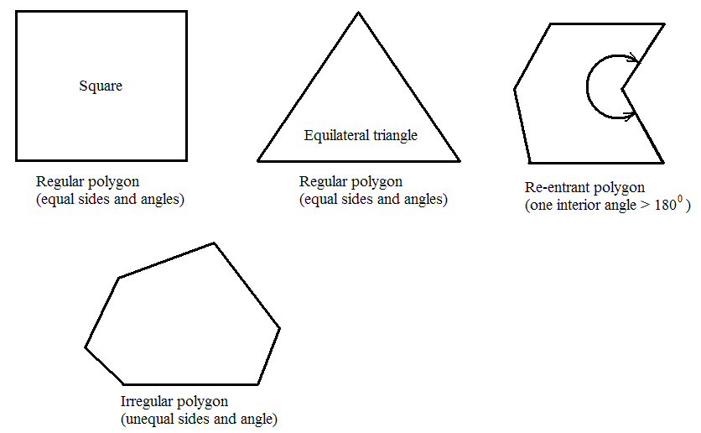

Polygons are named based on the number of sides they have. A polygon with three sides is called triangle, four sides is quadrilateral, pentagon 5, hexagon 6, heptagon 7, octagon 8, nonagon 9 and decagon 10 sides. These could either be regular or irregular.

**Evaluation Questions**

1. Define a polygon. Give examples.

2. With the aid of suitable diagrams, state three types of polygon.

**Construction of polygons.**

There are two methods of constructing polygons and these include (i) ***Exterior angle method.*** (ii) ***Circumscribing circle method***. In the external angle method, the number of sides, N of the required polygon is used to divide 3600 in order to determine the exterior angle to which that particular polygon is to be drawn. For instance, a regular pentagon with 5 sides will have its sides drawn to an exterior angle of 720

Similarly, a regular hexagon with six sides will have its exterior angle drawn at 600, heptagon 520, octagon 450, nonagon 400 etc.

The circumscribing circle method has the polygon enclosed in a circle of known diameter.

***To construct a regular pentagon using the exterior angle method***.

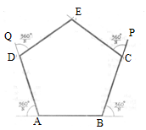

**Method:**

(i) Divide 3600 by the number of sides N which in this case is 5 to obtain an exterior angle of 720.

(ii) Draw a line AB equal to the length of one side of the regular pentagon.

(iii)With a protractor at point A, measure in a clockwise direction angle 720. Draw the line AQ and mark

off the given length on it to obtain point D.

(iv) Repeat same for point B in an anti-clockwise direction to obtain point C.

(v) Repeat the same for points C and D to obtain point E. ABCDE is the required pentagon.

***To construct a regular pentagon using the circumscribing circle method.***

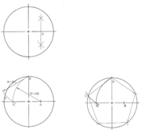

**Method:**

(i) Draw the given circle that will

circumscribe the pentagon.

(ii) Bisect the radius to locate point A.

(iii)With A as centre and radius AB, swingan

arc to cut the horizontal diameter line at point C.

(iv)With B as centre and radius BC, swing an arc

to cut the circle at point D.

(v) Join DB which is the length of one side of the pentagon.

(vi)Step- off the length DB round the circle to obtain the remaining sides of the pentagon.

***To construct a regular hexagon using the exterior angle method when given the length of one side.***

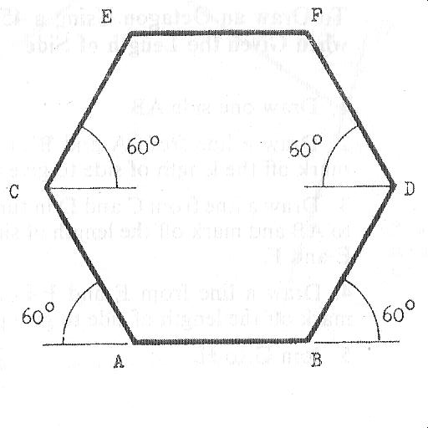

**Method:**

(i) Determine the size of the exterior angle by dividing 3600 by 6 (hexagon) which gives 600.

(ii) Draw a line AB equal in length to the given side.

(iii)Using 600 setsquare or protractor, draw lines AC, BD, CE, DF and EF of equal length with AB to

complete the hexagon.

***To construct a regular hexagon when given the distance across corners using circumscribing circle method.***

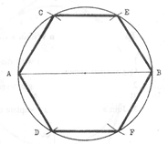

**Method:**

(i) Draw a circle of radius equal to the given length of side.

(ii) Draw a horizontal diameter AB.

(iii)With A and B in turn as centre and radius equal to the radius of the circle, swing arcs C and D and

arcs E and F respectively.

(iv)Join AC, AD, BE, and BF to complete the hexagon.

***To construct a regular octagon when given the length of side using the exterior angle method.***

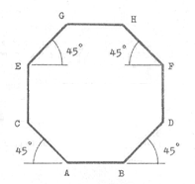

**Method:**

(i) Determine the size of the exterior angle thus: .

(ii) Draw a line AB equal to the length of one side of the regular octagon.

(iii) Draw a line from A and B in turn at 450 and mark off the given length of side on each to give points

C and D.

(iv) Draw a line from C and D in turn perpendicular to AB and mark off the given length of side on each

line to give points E and F.

(v) Draw a line from E and F in turn at 450 and mark off the given length of side on each line to obtain

points G and H.

(iv)Join GH to complete the required octagon.

***To construct a regular octagon using the circumscribing circle method when given the distance across flats.***

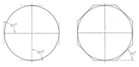

**Method:**

(i) Draw a circle of diameter equal to the distance across flats.

(ii) Draw centre lines (vertical and horizontal).

(iii)Draw horizontal lines on each side of the circle tangent to the circle at the vertical centre line.

(iv)Draw vertical lines on each side of the circle tangent to the circle at the horizontal centre line.

(v) Complete the octagon by drawing the remaining four lines tangential to the circle and in a way that they intersect the horizontal and vertical lines previously drawn.

***To construct a regular octagon by bisecting the four quadrants when given distance across corners.***

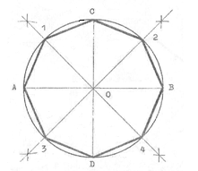

**Method:**

(i) Draw the circle of diameter equal to the given distance across corners.

(ii) Draw the horizontal and vertical diameters respectively AB and CD to obtain the four quadrants.

(iii)Bisect each of the quadrants to obtain points 1, 2, 3 and 4 on the circumference of the circle.

(iv)Join all the points to complete the octagon.

***To construct any polygon when given the diagonals e.g a regular pentagon.***

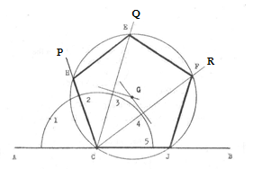

**Method:**

(i) Draw a line AB of any length.

(ii) Mark any point C on the line and construct a semi-circle of convenient radius at this point.

(iii) Divide the semi-circle by trial method into the same number of equal parts depending on the

number of sides of the required polygon.

(iv) Radiate lines from point C through point 2, 3 and 4. *Note that the first line must always be drawn*

*through the second division.*

(v) Draw CE and CF equal to the given diagonals.

(vi) Bisect CE and CF and their bisectors intersect at point G.

(vii)With G ascentre and radius CG, draw a circle which cuts lines CP, CQ, CR, and CB at points H, E,

F, and J respectively. Join HE, EF and FJ to complete the regular pentagon.

*GENERAL METHODS OF CONSTRUCTING POLYGONS*

***To construct a regular heptagon when given the distance across corners.***

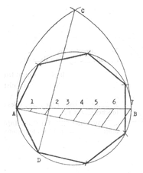

**Method:**

(i) Draw the circle using the given distance across corners, (d/c). Divide the horizontal diameter AB intoequal number of sides of the polygon you are required to construct. In this case, divide it into 7 equalparts.

(ii) With points A and B in turn as centre and radius AB, draw arcs to intersect at point C.

(iii) Draw a line from point C through the second division to touch the circle at point D.

(iv) Join AD which represents one side of the heptagon.

(v) Step off the length AD round the circumference of the circle to obtain the remaining sides.

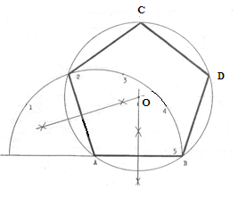

***To construct any polygon when given the length of side.***

**Method:**

(i) Draw one side AB and extend it to the left.

(ii) With A as centre and radius AB, draw a

semi-circle and divide it by trial into as many

equal parts astherequired polygon has.

(iii) Join A-2 which is the second division on the semi-circle.

(iv) Draw the bisectors of AB and A-2 and these bisectors intersect at point O.

(v) With O as centre and radius equal to OA or OB, draw a circle.

(vi) Mark-off the length AB or AD round the circumference of the circle to get points C and D.

Join 2C andCD to obtain the required polygon.

***To construct a number of polygons on a given base.****(two*- *triangle method)*

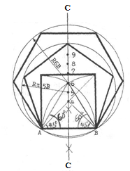

**Method:**

(i) Draw a line AB equal in length to the given base.

(ii) Draw the perpendicular bisector of line AB ie line C-C.

(iii)Construct two triangles with base angles of 450 and 600

on line AB. The apices of these triangles marked

4 and 6 are respectively the centers that will circumscribe

a regular polygon with four and six sides oflength AB respectively.

(iv)Bisect the distance between 4 and 6 to obtain point 5 which is the

centre for the circle that will circumscribe a regular polygon with five sides of length AB.

(v) Step off the distance between 4 and 5 or 5 and 6 along the bisector C-C to obtain centers for circles

thatwill circumscribe a heptagon, octagon, nonagon etc.

**Evaluation Questions**

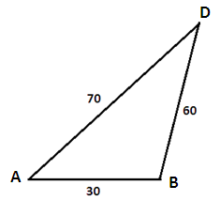

1. In the diagram shown above, AD and BD are the two diagonals of a pentagon ABCDE whose

sides are BC= 40, CD = 35, DE = 55 and angle DEA = 900. (i) construct the pentagon.

(ii) state the length AE of the pentagon.

2. On the same base of length 30mm, construct the following regular polygons; square, pentagon,

hexagon, heptagon, octagon, nonagon and decagon.

3. Construct a nonagon when given the distance across corners A/C = 40mm. Use a general method.

4. An irregular hexagon ABCDEF has the following dimensions. AB = 51, BC = 30, CD = 23,

DE = 36 EF = 30, AD = 70, AF = 38, < FAB = 1100, < ABC = 880. Use the information above to

constructthehexagon.

**General evaluation/ revisional questions**

1. On the same base of length 40mm, construct the following regular polygons; square, pentagon, hexagon, heptagon, octagon, nonagon and decagon.
2. Determine graphically the circumference of a circle, diameter 35mm.
3. Construct a pentagon when given a diagonal of 70mm.

**Reading assignment**

Technical drawing by JN Green. Pages 28-33,38,63.

**Weekend Assignment**

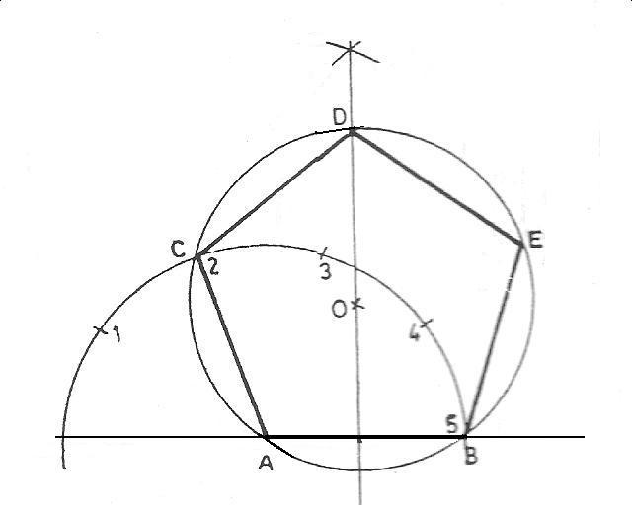

**Objective**

1. The figure above shows a general method of constructing a regular polygon when given the

A. numberof sides. B. diagonal. C. diameter. D. length of sides.

2. Which of the following is required to construct the polygon below? A. Distance across flats.

B. Distance across corners. C. Internal angle. D. Length of one side.

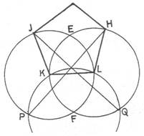

3. The figure below shows the beginning of the construction of a/an A. cylinder. B. triangle.

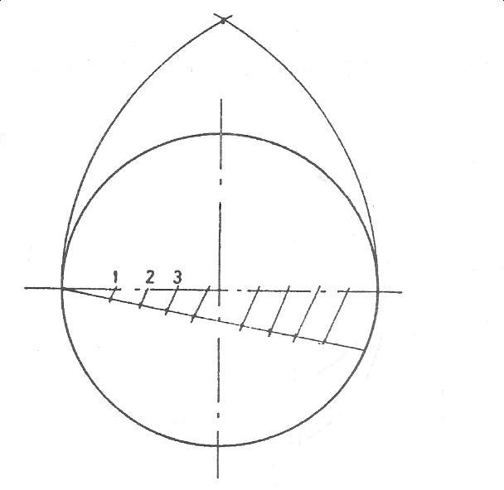

C. regularpolygon. D. circle.

4. Which of the following polygons shown below is refered to as re-entrant polygon?

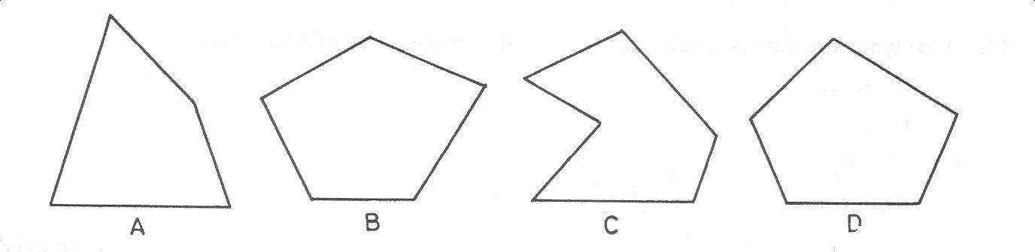

5. Which of the following will be produced by completing the construction below? A. Hexagon.

B. Octagon. C. Pentagon. D. Decagon.

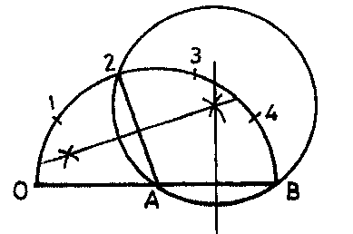

**Theory**

1. In the diagram shown below, AD and BD are the two diagonals of a pentagon ABCDE whose

sides are BC= 40, CD = 35, DE = 55 and angle DEA = 900. (i) construct the pentagon.



(ii) state the length AE of the pentagon.

2. An irregular hexagon ABCDEF has the following dimensions. AB = 51, BC = 30, CD = 23,

DE = 36EF = 30, AD = 70, AF = 38, < FAB = 1100, < ABC = 880. Use the information above to

construct thehexagon.

**WEEK FOUR DATE:………………**

**Topic: Plain scales and their uses**

**Content:**

(i) Meaning of plane scale.

(ii) Construction of plane scales.

Meaning of plane scale

A scale is used to measure or lay out a line on a drawing in full size, or larger or smaller than full size. The term scale also refers to the ratio of the size of a drawing to the actual object. This ratio or fraction is called the *Representative Fraction* of a scale.

Representative fraction (RF) = distance or size drawn

distance or size represented

The representative fractions of the most commonly used scales are as follows:

1:1{full size­­­­}

1:2{half full size}

1:5{one-fifth full size}

1:10{one-tenth full size}

2:1{twice full size}

5:1{five times full size}

The most commonly used scales are plain and diagonalscxles

Plain scale: A plain scale has two units of measurement. They are metres and decimetres. Scales such as 1:2, 1:5, and 1:100 can be used direct from a standard scale rule. Other scales, for example, 1:21/2, would need to be constructed

Evaluation Questions

1. Define representative fraction.



2. What is a plain scale?

Construction of plain scale.

*To construct a plain scale of 1: 21/2 to show a maximum of 400mm and a minimum of 10mm.*

**Method**:

(i) Workout the total or maximum length of the scale. 1: 21/2 x 400mm = 160mm



(ii) Draw a line 160mm long and divide it into four (4) equal parts of 40mm units each. (iii) The height of the scale can be any convenient height.

(iv) Divide the first part (40mm) into 10 equal parts.

(v) Print the scale ratio and number the divisions.

*Note:* the scale is used by taking hundreds to the right of zero and tens to the left. It is best to use

dividers to mark sizes from the scale. The values of X and Y are respectively 280mm and 130mm.

*To construct a scale of 2cm equals 1metre to read up to 6m in decimeter*

Method:

Every 2cm drawn is equal to 1m (100cm) of the actual object. Therefore scale ratio = 2 : 100 or 1 : 50



(i) Calculate the total length of the scale rule : If every 2cm on the scale rule is

equivalent to 1m, therefore a scale rule that could read up to 6m will have

a total length equal to (2 x 6) cm i.e. 12cm or 120mm.( 2/100 x 600) = 12cm = 120mm.

(ii) Draw a line 120mm long and divide it into 6 equal parts of 20mm units each.

(iii) The height of the scale rule could be any convenient length

(iv) Divide the first unit into 10 equal parts.

*To construct a scale of 3cm Equals 1dm (10cm) to read up to 4dm in centimeters.*

Method:

Every 3cm drawn is equal to 1dm (10cm) of the actual object. Therefore, scale ratio = 3 : 10 or 1 : 31/3

(i) Calculate the total length of the scale rule : If every 3cm on the scale rule is equivalent to 1dm,

therefore a scale rule that could read up to 4dm will have a total length equal to (3 x 4) cm i.e. 12cm



or 120mm.( 3/10 x 40 ) = 12cm = 120mm

(ii) Draw a line 120mm long and divide it into 4 equal parts of 30mm units each.

(iii)The height of the scale rule could be any convenient length

(iv)Divide the first unit into 10 equal parts.

*To construct a scale of 11/2 times full size to read up to 8cm in millimeters*

Method:

Scale ratio = *11/2* x 1 (full size = 1:1)

(i) Draw a line of length equal to (*11/2*x 8) cm i.e 12cm or 120mm and divide it into 8 equal parts.

(ii) The height of the scale rule could be any convenient length.

(iii) Divide the first unit into 10 equal parts.



*To construct a scale of 1/3 to read up to 4dm in centimeters.*

Method:

*1/3* in this case, means to divide 1dm into three equal parts.

(i) Draw a line 1dm long and divide it into 3 equal parts, each of which will represent 1dm on the scale.

(ii) Step off one of these parts to give the required 4dm

(iii) The height of the scale rule could be any convenient length.

(iv) Divide the first unit into 10 equal parts.

General valuation/revision Questions

1. Define representative fraction.

2. Construct a scale of 4cm equals 2dm to read up to 5dm in centimeters.

3. Construct a scale of 21/2 times full size to read up to 6cm in millimeters

4. Construct a scale of 1/4 to read up to 7dm in centimeters.

5. The length of a piece of land is 6.50km. If the land is measured on a scale of 1:500, what will be the

reading in mm on the scale rule?

6. Construct a scale of 20cm equals 1m to read up to 6m in millimeters. Use the scale

to draw the figure shown below.



**Reading assignment**

Technical drawing for school certificate and G.C.E by J.N Green Page 36-37

**Weekend Assignment**



**Objective**

1. What are the readings on the following scale rule marked X and Z ?A. 87 mm and 390 mm

B. 86 mm and 380mm C. 85 mm and 370 mm.D. 68mm and 290mm.

2. What is the length of a line 3m long on a scale of 1:50. A. 25mm B. 60mm C. 45mm. D. 52mm.

3. How many units of measurement has a plain scale? A. 3 B. 2 C. 5 D. 4

4. The rulers in your mathematical set were constructed to measure to a scale ratio of A. 1:2

B. 1: 1 C. 2:3 D. 1:5

5. Which of the following is not an enlargement scale? A. 5: 3 B 3: 4 C. 2:1 D. 3:2.



**Theory**

1. Draw the diagram below to a scale of 1:2.

2. The only measurements available on the drawing of an ornamental gate shown below



are 2100mm and 300mm sizes. Find the scale of the drawing and measure the other

sizes; A, B, C, D and E. (Hints: R.F = drawn/ actual size)

**WEEK FIVE DATE:………………**

**Topic:** Diagonal and chordal scale and their uses.

Content:

(i) Meaning and construction of diagonal scales.

(ii) Scale of chords and its construction.

Meaning and construction of diagonal scales.

Diagonal scale: Diagonal scales unlike plain scale can measure to a fine degree of accuracy with three units of measurement; centimeters, millimeters and tenths of a millimeter. This is the singular advantage of diagonal scale over plain scale.



Construction of diagonal scale

*To construct a diagonal scale of centimeters to read up to 7cm in millimeters and tenths of a millimeter.*

Method:

(i) Draw a line 7cm long and divide it into 7 equal parts.

(ii) Divide the first part into 10 equal units

(iii) Draw the height AC of the scale rule to any convenient length and divide it into 10 equal parts.

Transfer same10 division to the first part AD

(iv) Project horizontal lines from each of these 10 divisions on the height AC.

(v) Project vertical lines from each of the division on line AB. Draw diagonal lines in between the 10

vertical lines of the first part as shown above.

*Note:* Diagonal scale is read from the highest unit to the smallest. The value of S is 4.66cm or 46.6mm

(4cm + 6mm + 6/10mm => 40mm + 6mm + 0.6mm)

*To construct a diagonal scale of twice full size to read up to 6centimetre in millimeters and tenth of a millimeter.*



Method:

(i) Draw a line 12cm long i.e. (2x6)cm and divide it into 6 equal parts.



(ii)Follow the same procedure as above. The value of X is 2.49cm or 24.9mm.

*To construct a diagonal scale of 3centimetres equal to 1metre and to read up to 4metres in decimeters and centimeters.*

**Method:**



(i) Draw a line 12cm long i.e. (3x4) cm and divide it into 4 equal parts.

(ii) Same procedure as above. The value of S is 1.93m or 19.3dm or 193cm.

*To construct a diagonal scale of 1/4 full size to read up to 5dm in centimeters and millimeters*

Method:

(i) Draw a line of length equal to 125mm i.e. (*1/4*x 5)dm => 1.25dm or 12.5cm or 125mm.

(ii) Same procedure as above. The value of Z is 3.93dm or 39.3cm or 393mm.

Evaluation Questions

1. What is diagonal scale?



2. Construct a diagonal scale of 2/5 full size to read up to 3 dm in centimeters and millimeters.

3. What is the difference between the values of k and n in the figure shown below?

The chordal scale: The chordal scale is used to construct angles that cannot easily be constructed using a ruler and a pair of compasses .For instance, to construct angles which are multiples of 50, a scale of chords showing a distance of 50 is constructed.

Construction of the scale of chords

***To draw a scale of chords to show distances of 50***



**Method:**

(i) Draw a quadrant ABC of any radius and divide the arc AC into 18 equal parts i.e. 50x18 = 900 which

is the angle in a quadrant.

(ii) Extend the base line AB of the quadrant to the right.

(iii) With 000 as centre and radius equal to each of the 18 divisions in turn, draw

arcs to touch the base line AB of the quadrant and its extension.

(iv) Construct the scale which could be of any convenient height below the quadrant.



This scale is used to construct the required angle.

***Example 1***

***Construct angle 250 using scale of chords*.**

(i) Draw a line PM of any convenient length.

(ii) With P as centre and radius R of length equal to the radius of the quadrant (00-600), draw an arc to cut

line PM at Q.

(iii) With Q as centre and radius r of length equal to the required angle (00-250) measured from the

constructed scale, draw an arc to cut the previous one at S.

(iv) Draw a line from P through S. <SPM is the required angle. Scale of chord is a type of scale that

can be used to construct angles other than the ones done with a pair of compasses eg 240, 370

etc.

General evaluation/ revision questions

1. Construct a scale of 4cm equals 2dm to read up to 5dm in centimeters.

2. Construct angle 400 using the scale of chords.

3. Construct angle 270 using the scale of chords.

4. Construct the following angles (i) 150 (ii) 750 (iii) 1050(iv) 1200 (v) 1500

**Reading assignment**

Technical drawing for school certificate and G.C.E by J.N Green Page 11-13.

**Weekend Assignment**

**Objective**

1. Which of the following scale can be used to construct angle 270 ? A. Plain scale B. Scale of chord

C. Diagonal scale. D. Linear scale.

2. Which of the following scale has the highest degree of accuracy? A. Plain scale B. Diagonal scale

C. chordal scale. D. Enlargement scale.

3. Which of the following scale has three units of measurement? A. Chordalscale B. diagonal scale

C. Reduction scale. D. Plain scale.

4. Centimeters, millimeters and tenths of a millimeter are units of measurement for A. diagonal scale

B. plain scale C. chordal scale. D. enlargement scale.

5. Which of the following is a reduction scale? A. 3 : 4 B. 5 : 4 C. 2 : 1 D. 3 : 2

**Theory**

1.Construct angle 500 using the scale of chords.

2. Construct a diagonal scale of 2/5 full size to read up to 3 dm in centimetres

andmillimetres.

**WEEK SIX AND SEVEN DATE:………………**

**Topic:** Reduction of plain figures

**Content:**

1. Reduction of similar figures
2. Enlargement of similar figures

**Reduction of similar figures**

**Example 1**: Draw a rectangle A1B1C1D1 similar to another rectangle ABCD reduced in the proportion

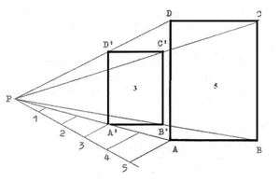

3:5

**Method:**

(i) Draw the given rectangle ABCD.

(ii) Mark a point P at a convenient distance to the drawn rectangle.

(iii) Radiate lines from point P to the four corners of rectangle ABCD.

(iv) Since we are to draw a reduced figure, it means that from the given proportion (3:5), the actual size

is 5 while the reduced size is 3. Therefore, divide line PA into 5 equal parts.

(v) At the third (3) part, draw a line A1D1 parallel to AD.

(vi) Repeat same for the remaining sides to obtain the required reduced rectangle A1B1C1D1.

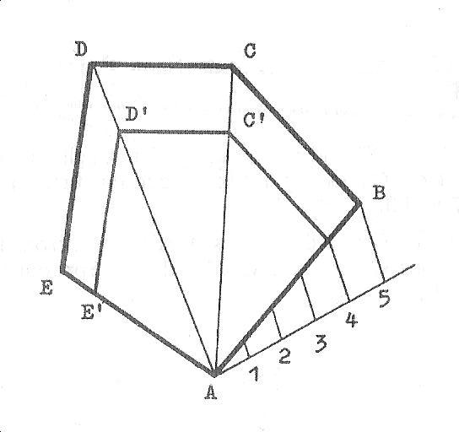

**Example 2**: Draw a polygon AB1C1D1E1 similar to another polygon ABCDE reduced in the proportion

4:5

**Method**:

(i) Construct the given polygon ABCDE using the data provided.

(ii) Radiate lines from point A through B, C, D, and E respectively.

(iii)Divide line AB into 5 equal parts.

(iv)From the fourth division, draw lines B1C1, C1D1 and D1E1 parallel to BC, CD and DE respectively to

complete the required reduced polygon.

**Example 3**: Draw a similar polygon of ratio 3:5 in area to a given polygon. *Note that* 3:5 *is a reduction scale.*

Method:

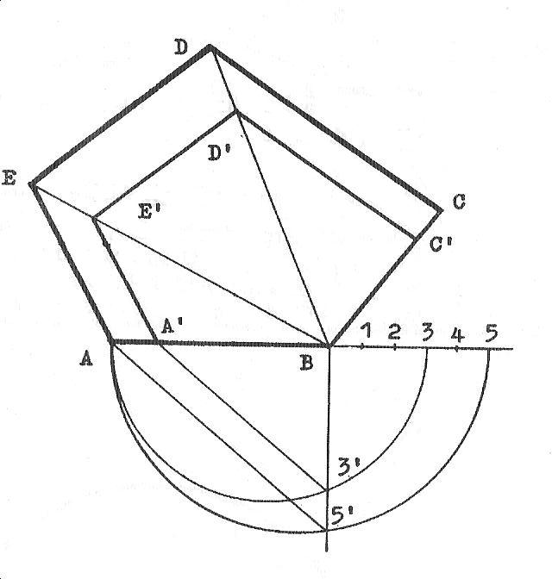

(i) Draw the given polygon ABCDE.

(ii) Radiate lines from point B to points D and E.

(iii) Extend line AB from point B.

(iv) Mark off on this line 5 equal unit of any convenient length.

(v) Draw semicircles on lines A-5 and A-3.

(vi) Erect a perpendicular at point B and this cut the two previously drawn

semicircles at 31 and 51 respectively. Join 51 to A since 5 is the actual size.

(vii) Draw a line from 31 parallel to line 51-A to meet line AB at A1.

(viii)From A1, draw a line A1E1 parallel to AE and repeat same to get the

remaining sides E1D1 and D1C1. This completes the polygon.

**Evaluation questions**

1. Construct a regular hexagon of side 40mm and reduce it by the ratio of 3:5
2. A photo frame is 40 by 60 in dimensions. Reduce it by the ratio of 4:7

**Enlargement of similar figures**

The method of enlarging similar figures is the same as that of reducing them. But it should be clearly

understood that while reduction reduces the size of the original object, enlargement increases it.

e.g2: 5 *is a reduction scale while 5*: 2 *is an enlargement scale*

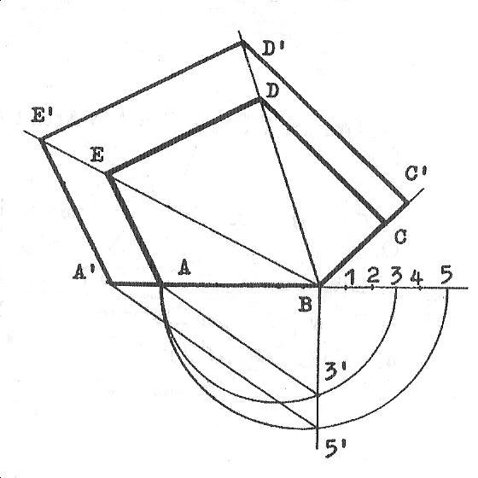

**Example 1**: Draw a similar polygon of ratio 5:3 in area to a given polygon. *Note that* 5:3 *is an enlargement scale.*

**Method:**

(i) Draw the given polygon ABCDE.

(ii) Radiate lines from point B through points D and E.

(iii) Extend line AB to both sides.

(iv) Mark off on AB extended 5 equal unit of any convenient length.

(v) Draw semicircles on lines A-5 and A-3.

(vi) Erect a perpendicular at point B and this cut the two previously drawn

semicircles at 31 and 51 respectively. Join 31 to A since 3 is the actual size.

(vii) Draw a line from 51 parallel to line 31-A to meet line BA extended at A1.

(viii)From A1, draw a line A1E1 parallel to AE and repeat same to get the remaining sides E1D1 and

D1C1.This completes the polygon.

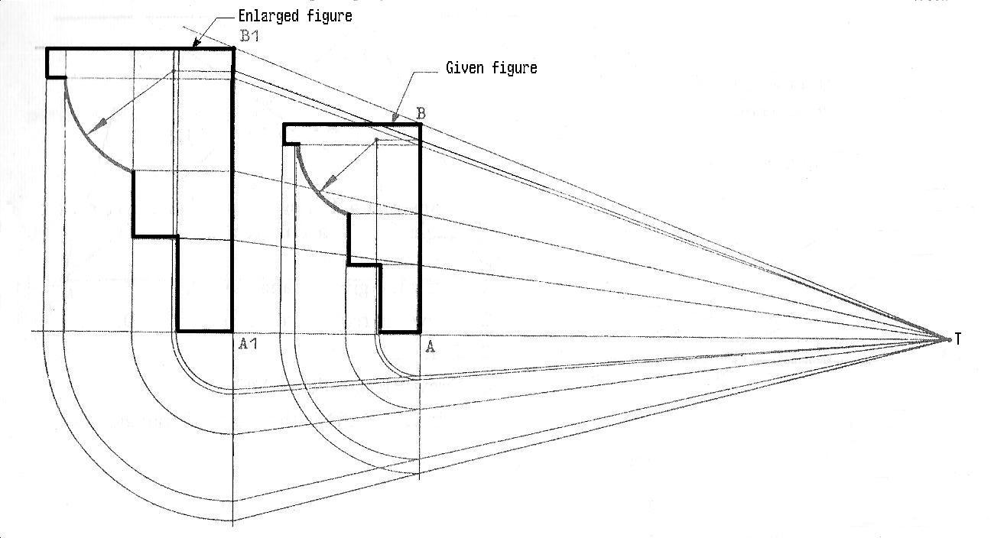

**Example 2:** To draw an enlarged figure similar to a given figure.

**Method:**

(i) Draw the given figure of height AB.

(ii) Extend its base line in both directions and indicate

the pole T on it at a convenient distance from the

given figure.

(iii) Radiate lines from point T through all the visible edges

of the figure which are traced perpendicularly to side AB.

(vi) The radiated line through points A and B forms the range

to which the height A1B1 of the required enlargement is drawn.

(v) With A as centre and radius equal to the distance between A and each vertical projection of the

visible edges on the base line, draw arcs to locate points on BA produced.

(vi) Radiate lines from T through each point on BA produced and these lines meet B1A1 produced at

points whichwill help to locate their respective points on the enlarged figure.

(vii)With A1 as centre and radius equal to each point on B1A1 produced, draw arcs to touch the base

line.

(viii)Project these lines upwards to locate points on the enlarged figure.

**Evaluation questions**

1. Construct a regular pentagon ABCDE of sides 30mm. Enlarge it in the ratio of 3:2

**General evaluation/ revision questions**

1. Construct a pentagon ABCDE whose sides are AB = 40, BC = 35, CD = 65, AE = 45, ED = 55, < ABC = 1200

and< BAE = 1050. Draw a similar pentagon of ratio 3:5 in area to the one constructed.

2. On the same base of length 30mm, construct the following regular polygons; square, pentagon, hexagon,

heptagon, octagon, nonagon and decagon.

3. Construct a nonagon when given the distance across corners A/C = 40mm.Draw a similar nonagon of ratio

5:4 in areato the constructed one.

4. An irregular hexagon ABCDEF has the following dimensions. AB = 51, BC = 30, CD = 23, DE = 36

EF = 30, AD = 70, AF = 38, < FAB = 1100, < ABC = 880. Use the information above to construct the

hexagon. Draw a similar hexagon of ratio 3:5 in area to the one constructed.

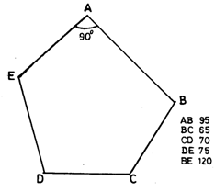

5. The figure above shows an irregular pentagon. Construct (i) the pentagon. (ii) a similar pentagon reduced in

area in the ratio 5:7

**Reading assignment**

Technical drawing by JN Green. Pages 28-33,38,63,76-79.

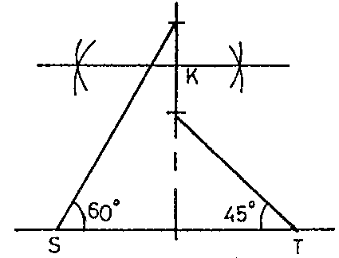

**Weekend Assignment**

**Objectives**

1. What type of polygon could be constructed with K as the centre in the figure above? A. Square.

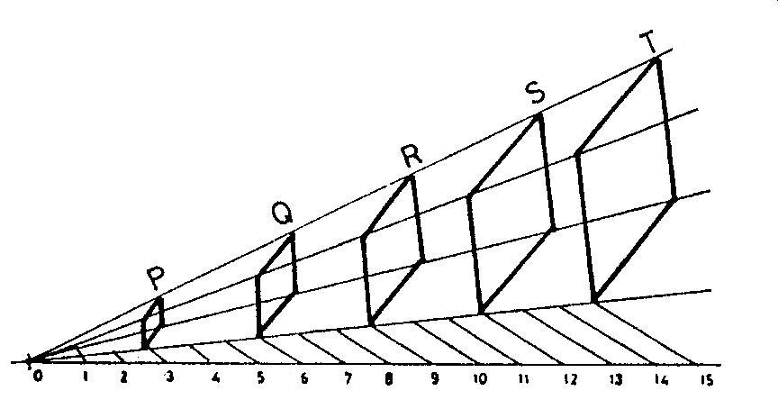

B. Pentagon.C. Hexagon. D. Heptagon.

2. Which of the labeled quadrilaterals in the diagram above have their sides in ratio 1:4?A. P and Q.

B. Q and R.C. P and S.D. R and T.

3. The figure below shows three irregular hexagons J, K and M. What is the ratio of their sides?

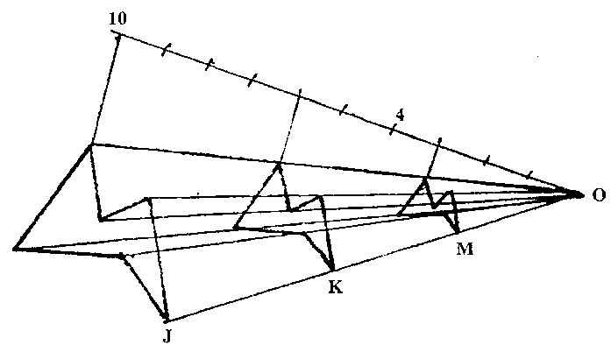

A. 10 : 4 : 3

B. 10 : 6 : 3

C. !0 : 2 : 3

D. 10 : 3 : 4

4. In the method of enlargement shown below, point O is taken at A. 10mm from point P.B. 20mm from point Q. C. a distance equal to the length of PQL. D. any convenient distance from L.

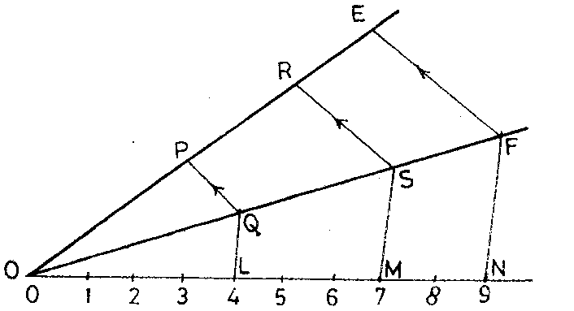

5. In the diagram below, the ratio of the sides of rectangle ABCD to the sides of rectangle A1B1C1D1 is A. 7:5

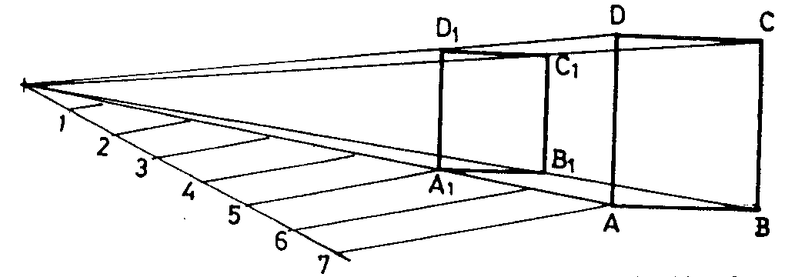

B. 5:7 C. 5:2 D. 4:7

**Theory**

1. In the diagram shown below, AD and BD are the two diagonals of a pentagon ABCDE whose sides are



BC= 40, CD = 35, DE = 55 and angle DEA = 900. (i) construct the pentagon. (ii) state the length AE of the

pentagon.

2. An irregular pentagon ABCDE has the following dimensions. AB = 51, BC = 30, CD = 23, DE = 36

EA = 38, < EAB = 1100, < ABC = 880.

(a) Use the information above to construct the pentagon.

(b) Construct a similar figure A1B1C1D1E1 which has an area of ratio 5:3 to ABCDE.

**WEEK EIGHT-NINE: DATE:………………**

**Topic: Equal area of planefigures**

**Content:**

1. Examples on equivalent area of plane figures.
   * ***Triangles equal in area to given polygons***

Example1: To construct a triangle equal in area to a given polygon with interior angle less than 1800

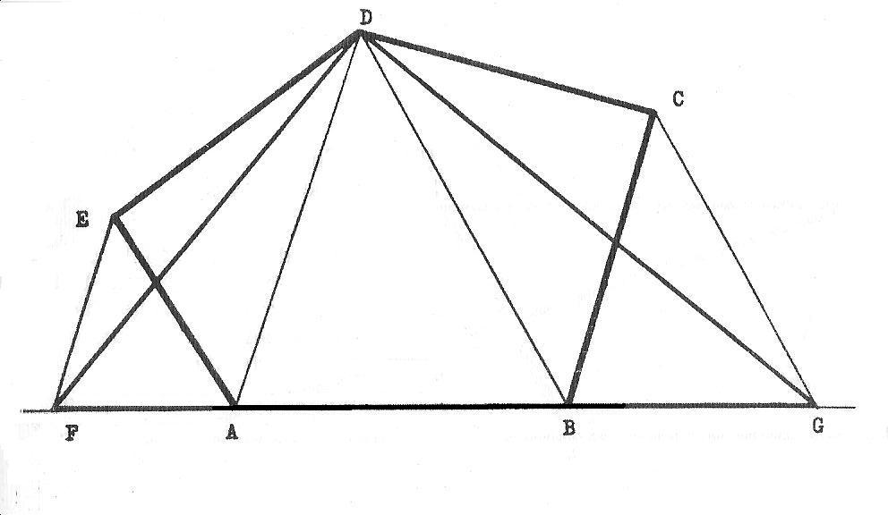

Method:

1. Construct the polygon ABCDE using the given data.
2. Extend the base line AB in both directions.
3. Join DA and DB.
4. Since angle E is opposite to line DA, draw a line from point E parallel to line DA to meet BA extended at point F. Repeat same for point C to get point G.
5. Join DF and DG.
6. Therefore, FGD is the required triangle.

**Example 2** To construct a triangle equal in area to a given polygon with an interior angle greater than

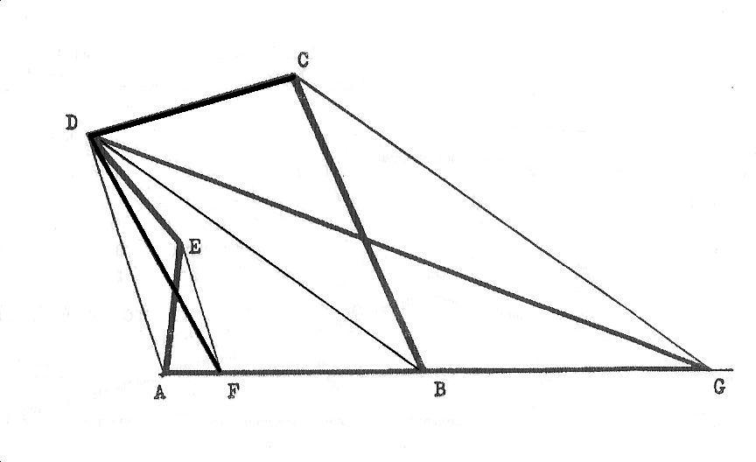

1800.

Method:

(i) Construct the polygon ABCDE using the given data.

(ii) Extend the base line AB.

(iii) Join DA and DB.

(iv) Since angle E is opposite to line DA, draw a line from

point E parallel to line DA to meet line AB atpoint F.

Similarly, from point C draw a line parallel to DB

and this meets AB produced at point G.

(v) Join DF and DG.

(vi) Therefore, FGD is the required triangle.

**Example 3** To draw a triangle equal in area to a given regular polygon.

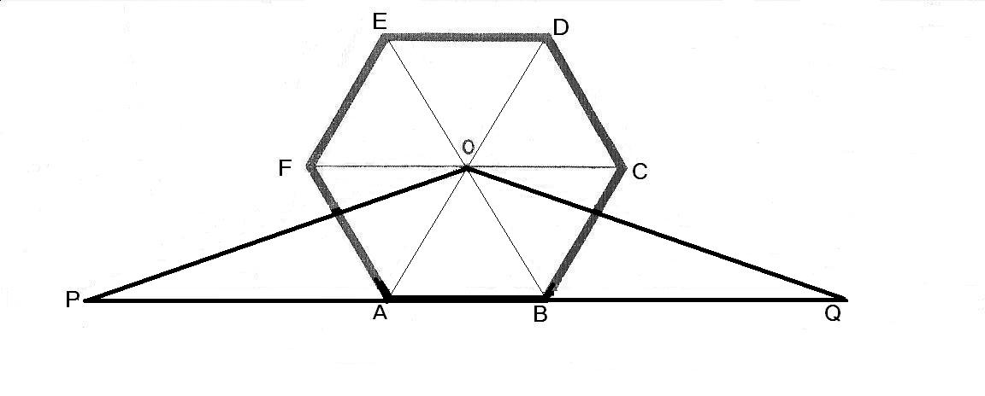

**Method:**

1. Construct the polygon ABCDEF using the given data.
2. Draw the diagonals of the polygon to intersect at point O.
3. Extend the base line AB in both directions to points P and Q respectively. Where PQ = sum of the length of sides of the polygon ie perimeter of the polygon.
4. Join OP and OQ to obtain the required triangle OPQ .
   * ***A triangle equal in area to a given parallelogram***

**Example 4** To construct a triangle equal in area to a given parallelogram.

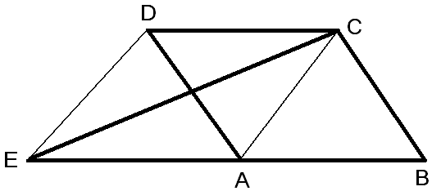

**Method:**

1. Construct the parallelogram ABCD using the given data.
2. Join point C to A.
3. Draw the base line BA produced.
4. Draw a line from point D parallel to CA and this meets BA produced Point E.
5. Join CE to obtain the required triangle CEB.
   * ***A parallelogram equal in area to a given triangle.***

**Example 5:** To draw a parallelogram equal in area to a given triangle.

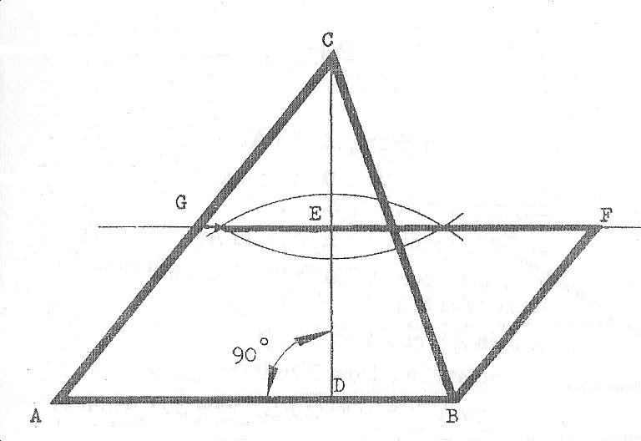

**Method:**

1. Draw the triangle ABC using the given data.
2. Draw a perpendicular line from the apex C to meet the base AB at point D.
3. Bisect line CD to get the mid point E.
4. Extend the bisector to both directions to locate point G.
5. Draw a line from point B parallel to AG and this meets the bisector at F.
6. ABFG is the required parallelogram.
   * ***A triangle equal in area to a given triangle but on a different base***

Example 6: To construct a triangle equal in area to a given triangle, but having a different base.

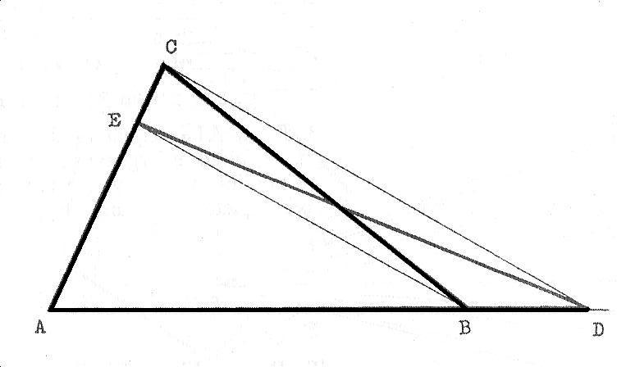

**Method:**

1. Construct the triangle ABC using the given data.
2. Extend the base AB by an amount equal in length to the base of the required triangle ie AD.
3. Join C to D.
4. Draw a line from B parallel to DC and this meets side AC at point E.
5. Join ED. Therefore, ADE is the required triangle.
   * ***A triangle constructed from its known area***

**Example7:** To construct a triangle when given the area.e.g let the given area be 41/2cm.

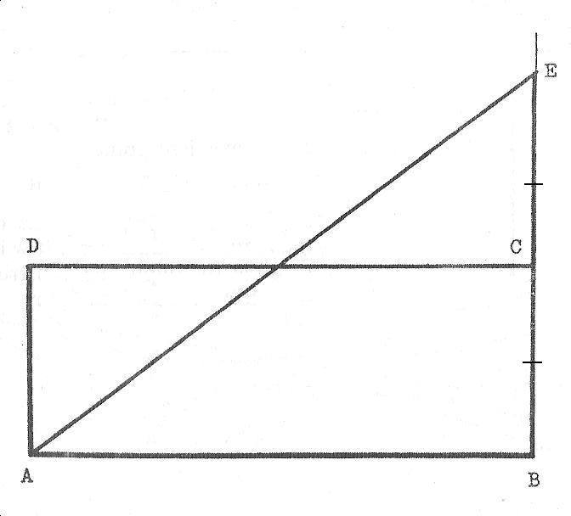

Method:

1. Draw any rectangle ABCD equal to the given area- 3cm x 11/2cm = 41/2cm.
2. Draw BC produced and mark off CE equal to BC on it.
3. Draw a line from E to A. Therefore, ABE is the required triangle.
   * ***A rectangle of different side equal in area to a given rectangle.***

**Example 8**: To draw a rectangle of different side but equal in area to a given rectangle.

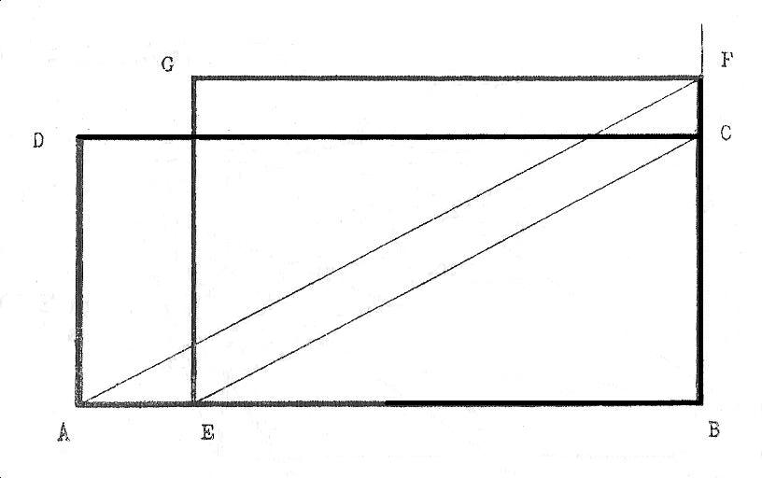

**Method:**

1. Construct the given rectangle ABCD.
2. Mark off BE on line AB where BE is the required different side.
3. Join EC.
4. Draw line BC produced.
5. Draw a line from A parallel to EC and this meets BC produced at F.
6. FB is the other side of the required rectangle. Complete the required rectangle EBFG.
   * ***A square equal in area to a given rectangle.***

**Example 9**: To draw a square equal in area to a given rectangle.

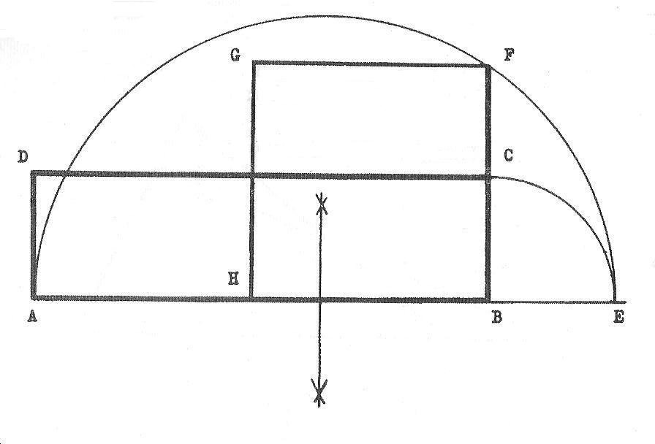

**Method:**

1. Construct the rectangle ABCD using the given data.
2. Draw line AB produced.
3. With B as centre and radius BC, swing an arc to cut AB produced at E.
4. Draw a semicircle on line AE and this cuts line BC produced at F.
5. BF is the length of side of the square.
6. With B as centre and radius BF, swing an arc on line BA to locate point H.
7. With H and F in turn as centres and same radius, locate point G.
8. HBFG is the required square.
   * ***A rectangle equal in area to a given triangle.***

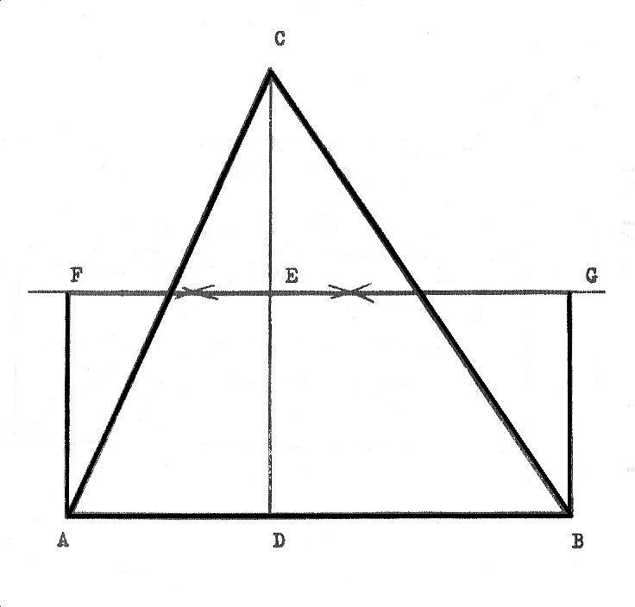

**Example 10:** To draw a rectangle equal in area to a given triangle.

**Method:**

1. Construct the triangle ABC using the given data.
2. From the apex C, draw a perpendicular line to

meet AB at point D.

1. Bisect line CD to locate the mid point E.
2. Draw a line through point E parallel to Line AB.
3. Erect perpendiculars at points A and B and these

meet the parallel line through E at points F and G respectively.

1. ABGF is the required rectangle.
   * ***A square equal in area to a given parallelogram.***

**Example 11:** To draw a square equal in area to a given parallelogram.

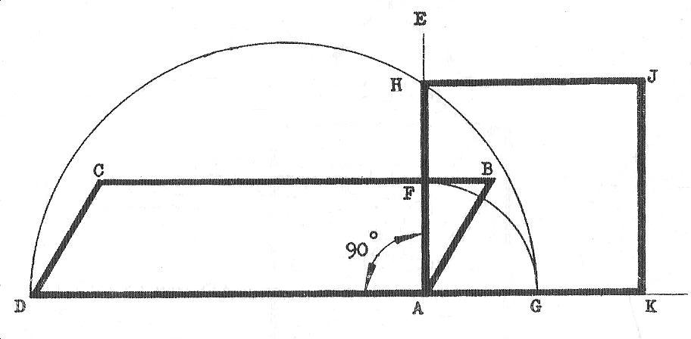

**Method:**

1. Construct the given parallelogram ABCD.
2. Draw DA produced.
3. Construct a perpendicular at point A and this cuts CB at F.
4. With A as centre and radius AF, swing an arc to cut DA produced at G.
5. Construct a semicircle on DG and this cut the perpendicular AE at H.
6. AH is the length of side of the required square.
7. With A as centre and radius AH, locate point K.
8. With H and K in turn as centres and same radius AH, locate point J.
9. AKJH is the required square.
   * ***Division of a triangle into a number of equal areas by parallel lines***

**Example 12:** To divide any triangle in a given number of equal areas eg four (4) by lines

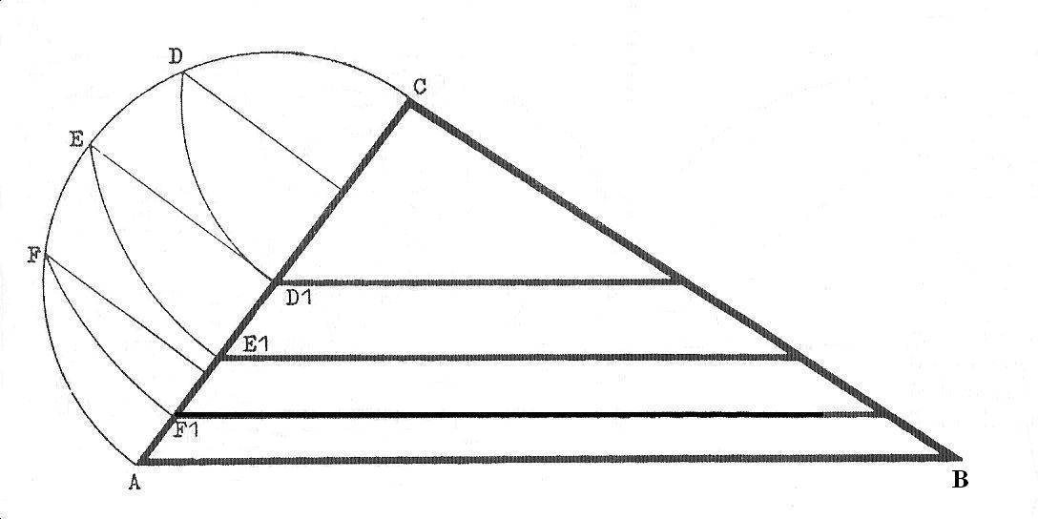

drawn parallel to one side.

**Method:**

(i) Construct the given triangle ABC.

(ii) Construct a semicircle on side AC.

(iii) Divide AC into 4 equal parts to produce four (4) equal areas. Three or two parts will produce 3 or 2

equalareas respectively.

(iv) Draw perpendiculars to AC from these 4 divisions and these cuts the semicircle at points F,E and D.

(v) With C as centre and radius CD, CE and CF in turn, swing arcs to touch AC respectively D1, E1 and

F1.

(vi) Draw lines from these points on AC parallel to line AB.

* + ***Division of a triangle into two equal areas by a perpendicular line.***

Example 13: To divide any triangle into two equal areas by a line perpendicular to one side.

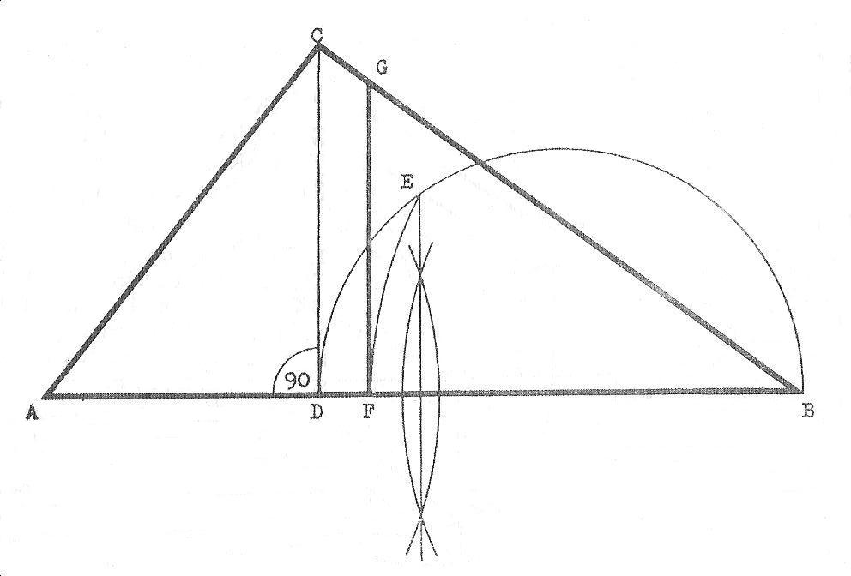

**Method:**

1. Construct the triangle ABC using the given data.
2. Draw a perpendicular line from the vertex C to meet AB at point D.
3. Construct a semicircle on DB.
4. Draw the bisector of line AB and this cut the semicircle at point E.
5. With B as centre and radius BE, swing an arc to cut AB at point F.
6. Draw a line from F parallel to DC and this meets line CB at G.
7. The line FG divides the triangle into two equal areas.

***Division of a triangle into two equal areas by a line drawn from a given point on one side.***

**Example14:** To divide any triangle into two equal areas by a line drawn from a given point

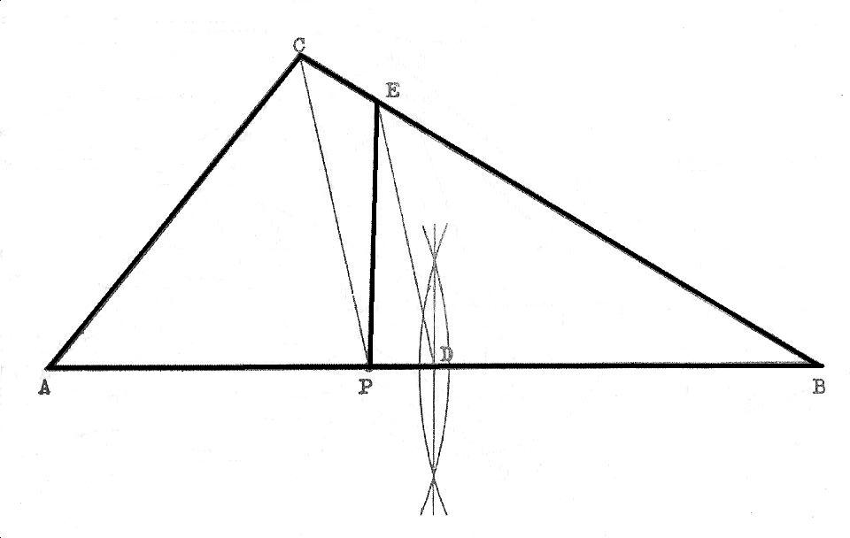

on one of its sides.

**Method:**

1. Draw the given triangle ABC indicating the given point P.
2. Draw a line from this point P to connect the vertex C.
3. Bisect line AB to obtain the mid point D.
4. Draw a line from point D parallel to PC and this meets CB at E.
5. Join EP which divides the given triangle into two equal areas.
   * ***A circle of equal area to the sum of two given circles.***

**Example 15:** To draw a circle equal in area to the sum of two given circles.

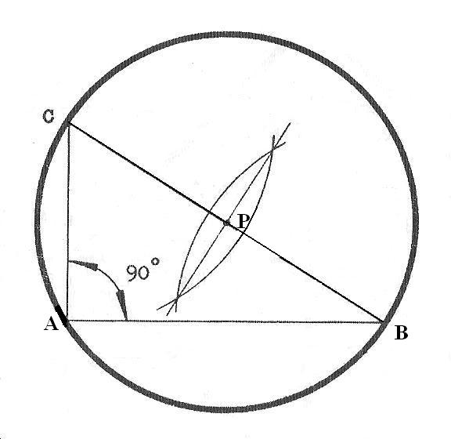

**Method:**

1. Draw a line AB equal in length to the diameter of one of the given circles.
2. Draw another line AC at right angle to AB equal in length to the diameter of the second given circle.
3. Join BC.
4. Bisect line BC so as to locate the centre P.
5. With P as centre and radius PA or PB or PC, draw the required circle.
   * ***A Square of equal area to the sum of two given Squares.***

Example 16: To draw a square equal in area to the sum of two given squares

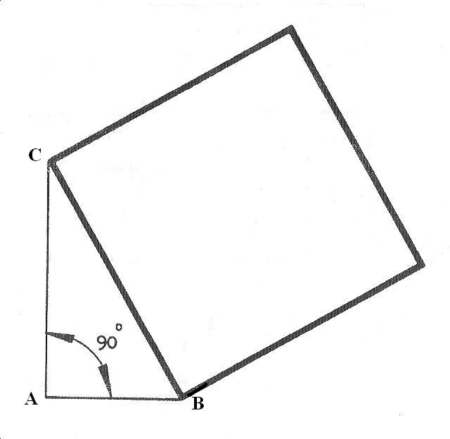

**Method:**

1. Draw a line AB equal in length to the side of one of the square.
2. Draw another line AC perpendicular to AB and equal to the length of the side of the other square.
3. Join BC. Then, construct a square on side BC. This is the required Square.
   * ***A Square of equal area to the difference of two given Squares.***

**Example 17:** To draw a square equal in area to the difference of two given squares.

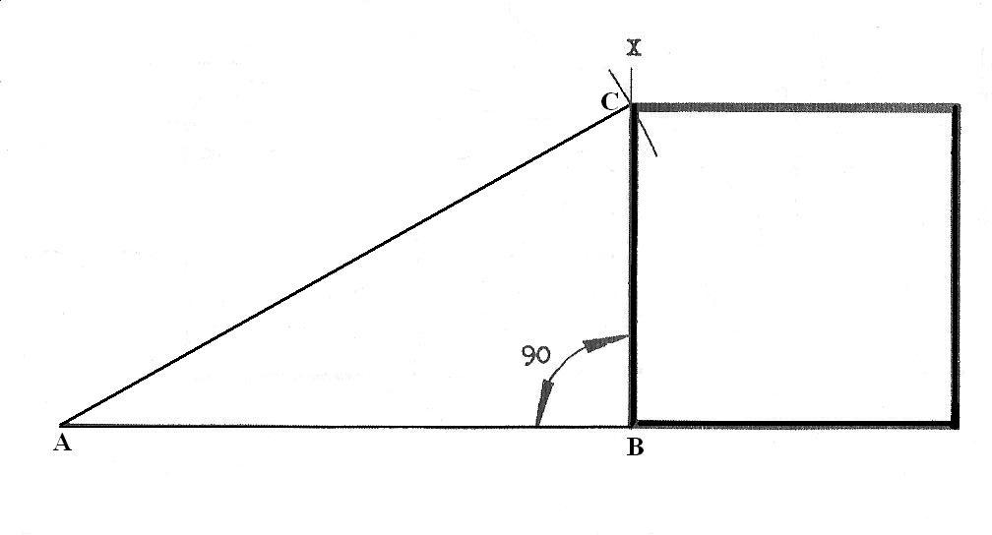

**Method:**

1. Draw a line AB equal to the length of side of the given smaller square.
2. Erect a perpendicular at B.
3. With A as centre and radius equal to the length of side of the given larger square, draw an arc to cut the perpendicular at point C.
4. Construct a square on BC. This is the required square.
   * ***A square twice the area of a given square.***

**Example 18**: To draw a square having Twice the area of a given square.

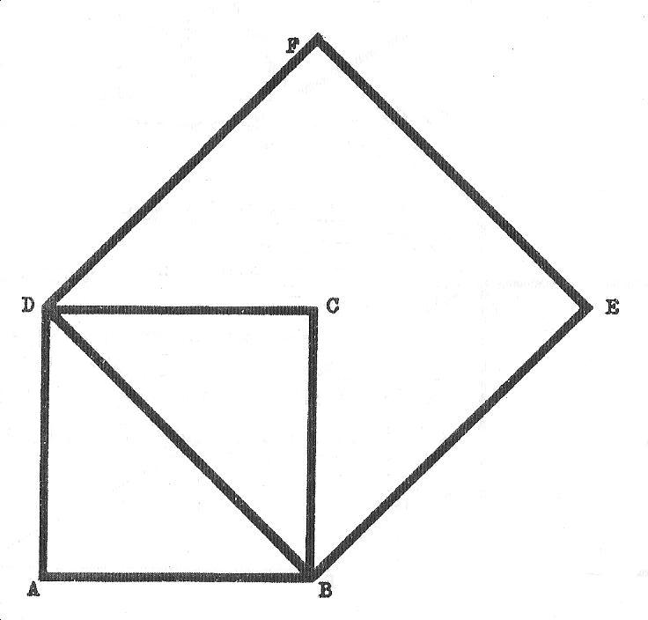

**Method:**

1. Draw the given square ABCD.
2. Draw the diagonal BD. This is the length of side of the required square.
3. Construct the square BDEF. This is the required square.

**Evaluation questions**

1. An irregular polygon is shown in the figure below.

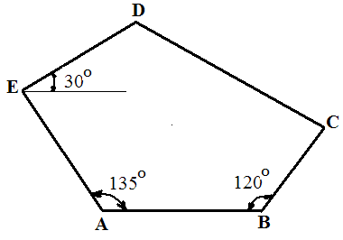

AB = 70

BC = 40

DE = 75

AE = 80

(a) Construct

(i) the pentagon;

(ii) a square equal in area to the given pentagon.

(b) Draw and state the length of a diagonal of the square in (a)(ii) above.

2.    In the figure below, **AD** and **BD** are the diagonals of a pentagon **ABCDE**whose sides are **BC = 40**,

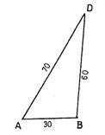

CD =35, DE = 55 and < DEA =900. (a)  construct the pentagon

  (b)  state the length of side **AE** of the pentagon.

(c)  reduce the pentagon in (i) above to a triangle of equal area

3. Construct a triangle ABC of sides AB = 50mm, AC = 60mm and BC = 55mm. Construct a

parallelogram equal in area with the triangle.

4. Construct a square equal in area to a rectangle whose length and breadth are respectively 60mm and

35mm.

5. Three equilateral triangles have their sides 40mm, 55mm and 65mm respectively. Construct another

trianglewhose area is equal to the sum of the areas of these triangles. State the length of its sides.

**Reading assignment**

Technical drawing by JN Green. Pages 80-92.

**Weekend Assignment**

**Objective**

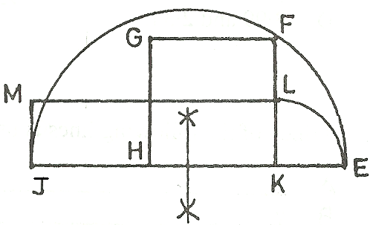

1. In the figure above, the area of rectangle JKLM is equal to A. half the area of semi-circle JFE. B. the area of square KFGH. C. half the area of square KFGH. D. the area of semi-circle JFE.

*Use the figure below to answer questions* 2 *and* 3.

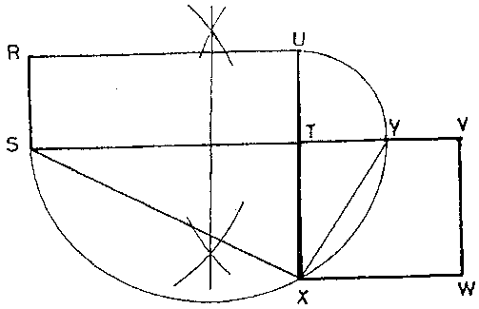

2. What is the ratio of the areas of rectangle RSTU and square TVWX? A. 1:1 B. 1:2 C. 1:3 D. 1:4.

3. What is the value of angle < SXY? A. 450. B. 600. C. 750. D. 900.

4. Which two triangles have the same area in the figure below?

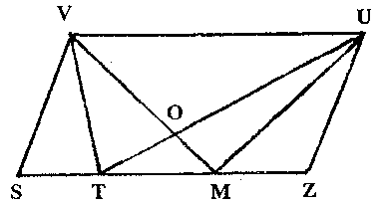

A. VTM and TUM.

B. TOM and MZU.

C. MUT and VST.

D. MOU and MVU.

5. Which of the following is equal in area to the polygon BCDEG shown below. A. CDG. B. CDGB.

C. ABGEF.D. AGF.

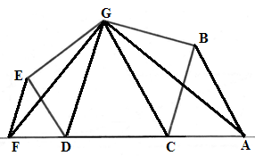

**Theory**

1. An irregular polygon is shown in the figure below.



AB = 70

BC = 40

DE = 75

AE = 80

(a) Construct

(i) the pentagon;

(ii) a square equal in area to the given pentagon.

(b) Draw and state the length of a diagonal of the square in (a)(ii) above.

2.    In the figure below, **AD** and **BD** are the diagonals of a pentagon **ABCDE**whose sides are **BC = 40**,



CD =35, DE = 55 and < DEA =900. (a)  construct the pentagon

  (b)  state the length of side **AE** of the pentagon.

(c)  reduce the pentagon in (i) above to a triangle of equal area

**WEEK TEN DATE:………………**

**Topic: Tangency involving circles, arcs and lines.**

**Content:**

(i) Principles of tangency.

**Principles of tangency.**

(i) To join an arc to a straight line or two straight lines inclined at different angles.

(ii) To join two arcs together externally.

(iii) To join two arcs together internally.

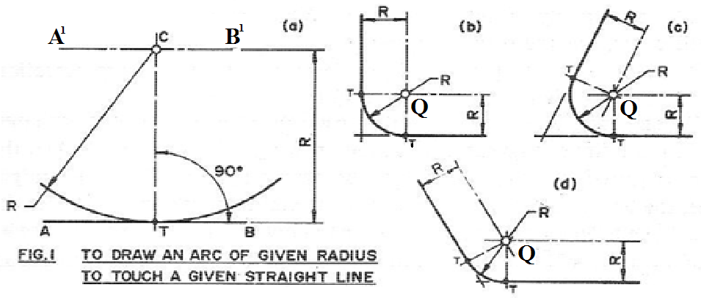

**1(a) To join an arc of known radius R to a straight line AB.**

**Method:**

(i) Draw the straight line AB.

(ii) Draw another straight line A1B1 parallel to line AB but at a distance R apart.

(iii) With compass pin at any given point on A1B1ie point C and radius R, draw an arc to touch line

AB.

**1(b) To join an arc of known radius R to two straight lines inclined at right angle.**

**Method:**

(i) Draw lines respectively at distance R parallel to the two given straight lines.

(ii) The point of intersection Q of these parallel lines in (i) marks the centre of the arc that would be

tangential to the two lines.

(iii) With Q as centre and radius R, draw an arc to just touch the two lines at their tangent points T.

*Note :*The procedures for drawing figures 1(c) and 1(d) are the same as figure 1(b) except that the two straight lines are inclined at acute and obtuse angles respectively.

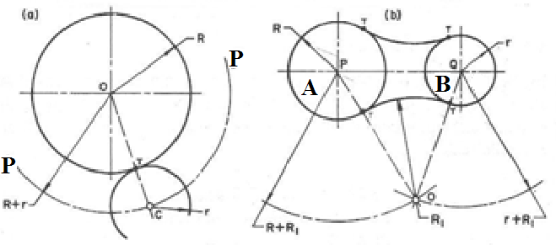

**Fig. 2**

**2(a) To join two arcs of known radius externally**.

**Example**: Given two arcs of radius r and R to be joined externally.[ **R + r** ]

**Method:**

(i) Draw the arc or circle of radius R.

(ii) With the same centre, draw another arc P-P of radius R + r where r is the radius of the arc or circle meant to have an external touch with the given circle or arc.

(iii) With the compass pin at any point on arc P-P and radius r, draw an arc to just touch the arc or circle of radius R at point T.

**2(b) To draw an arc of radius R1 to touch two circles externally.**

**Method:**

(i) Draw the two given circle A of radius R and circle B of radius r.

(ii) Join their centers ie P-Q.

(iii) With P as centre and radius R1+ R (where R1 is the radius of the arc meant to make an external

contactwith the two circles), draw an arc.

(iv) Also with Q as centre and radius R1+ R, draw another arc to intersect the former one at point O.

(v) Draw straight lines from point O to centers P and Q which cut both circles at their respective

tangentPointsT.

(vi) With O as center and radius OT, draw an arc to just touch circles A and B.

***To join two arcs together internally.***

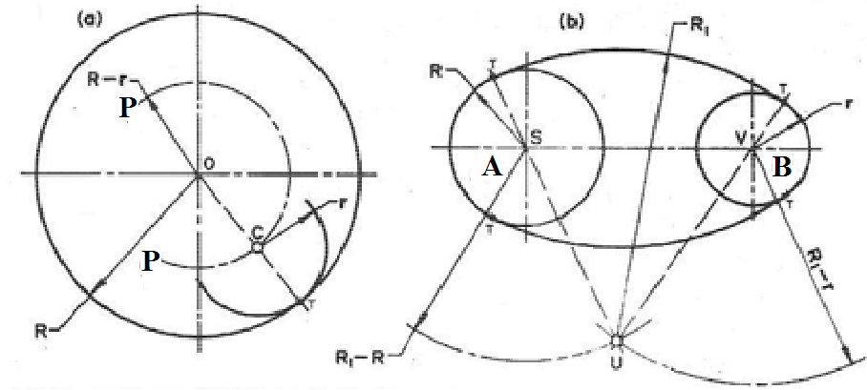

**Fig. 3**

**3(a) To join two arcs of known radius internally.**

**Method:**

(i) Draw the arc or circle of radius R.

(ii) Draw another arc P-P of radius [**R – r**] where r is the radius of the arc that is meant to touch the

other one internally.

(iii) With the compass pin at any point on arc P-P and radius r, draw an arc to just touch the arc or circle

ofradius R at point T internally.

**3(b) To draw an arc of radius R1 to touch two circles internally.**

**Method:**

(i) Draw the two given circles A of radius R and B of radius r.

(ii) Join their centresie S-V.

(iii) With S as centre and radius R1- R (where R1 is the radius of the arc that is meant to make internal contact), draw an arc.

(iv) Also with V as centre and radius R1 – r, draw another arc to intersect the former one at point U.

(v) Draw straight lines from point U through centers S and V to the tangent points T.

(vi) With U as centre and radius UT, draw an arc to just touch circles A and B at their respective

tangentpoints.

***To join an arc*** R2 ***externally with another arc*** AB ***and a straight line*** CD***.***

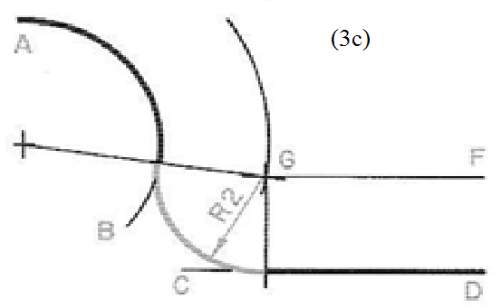

**Method:**

(i) Draw an arc parallel to arc AB and of radius equal to the radius of arc AB + R2.

(ii) Draw a line FG parallel to line CD at a distance equal to radius R2 to intersect the previous arc at G.

(iii) This point of intersection marks the centre of the arc of radius R2 that will connect the given arc AB and straight line CD.

***To draw a common external tangent to two circles of equal diameters.***

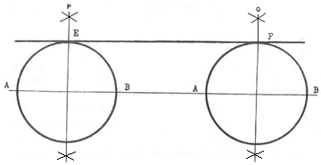

**Method:**

(i) Draw the two given circles.

(ii) Draw a line through the centers of the two circles.

(iii)Bisect the horizontal diameters AB of the two circles.

(iv)These bisectors which are respectively P and Q cuts each circle at points E and F.

(v) Draw a line through E and F. This is the required tangent.

***To draw a common external tangent to two circle of unequal diameters.***

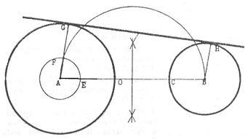

**Method:**

(i) Draw the two given circles.

(ii) Join the centers of the circles ie join A to B.

(iii) With O as centre and radius CB, mark off point E on line AB.

(iv) With A as centre and radius AE, draw a circle.

(v) Construct a semi-circle on AB and this cuts the previous circle at point F.

(vi) Draw a line from A through F and cutting the circumference of the larger circle at G.

(vii) Draw BH parallel to AG.

(viii)Draw a line through G and H. This is the required tangent.

***To draw a common internal tangent to two equal circles.***

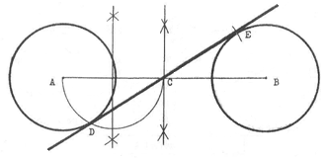

**Method:**

(i) Draw the two given circles.

(ii) Join the centers A and B of the two circles.

(iii)Bisect AB to get point C.

(iv)Construct a semi-circle on AC and this cuts the circle of centre A at point D.

(v) With C as centre and radius CD, draw an arc to cut the second circle at point E.

(vi)Draw a line through D and E. This is the required tangent.

***To draw a common internal tangent to two unequal circles.***

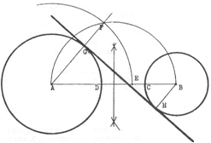

**Method:**

(i) Draw the two given circles.

(ii) Join the centers of the circles A and B.

(iii)With D as centre and radius CB, mark the point E on AB.

(iv)With A as centre and radius AE, draw an arc.

(v) Construct a semi-circle on AB to cut the previous arc at F.

**General evaluation/revision questions**

1. (a) Construct full size, the template shown below, showing clearly the

(i) centres of the arcs;

(ii) points of tangency.

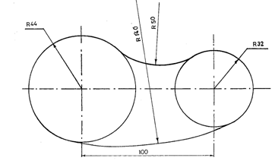

(b) Two circles P and Q, diameters 50 and 40 respectively, touch each other tangentially. Draw:

(i) the circles;

(ii) an arc R150, to include circles P and Q tangentially at the upper part;

(iii)an arc, radius 20, to exclude circles P and Q tangentially at the lower point.

2. Construct full size, the spanner shown below, showing clearly the (i) centres of the arcs; (ii) points

of tangency.

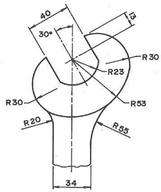

3. Construct half full size, the machine part shown below, showing clearly the (i) centres of the arcs;

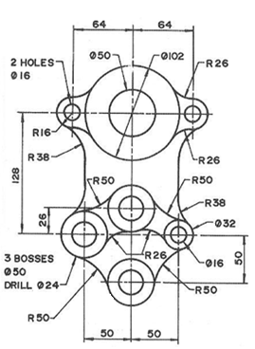

(ii) points of tangency.

4. Construct full size, the template shown below, showing clearly the (i) centers of the arcs; (ii) points

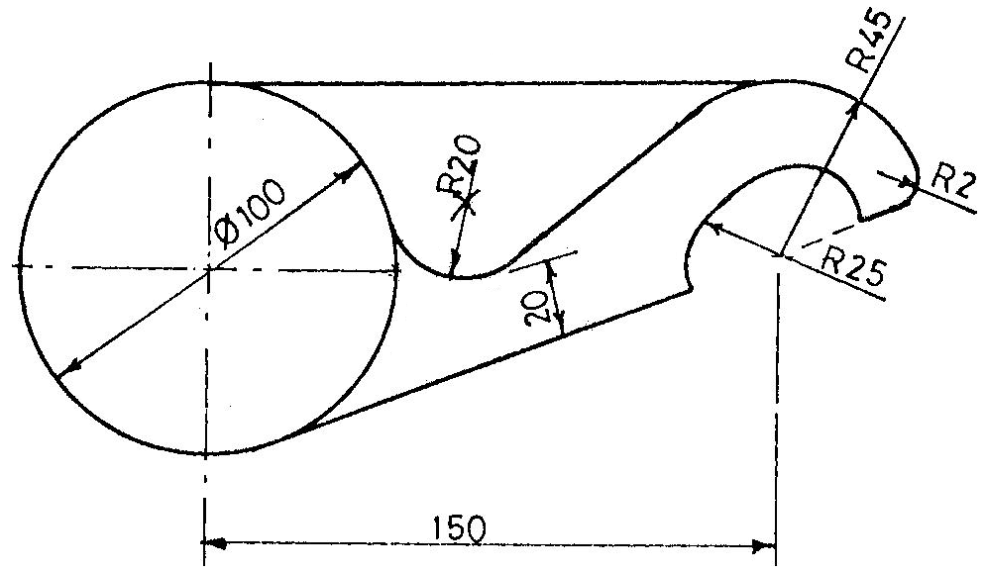

of tangency.

**Reading assignment**

Technical drawing by J.N Green,Pages 58 and 59

**Weekend Assignment**

**Objective**

1. Line X-X in the figure below is a common A. bisector. B. normal. C. external tangent. D. internal tangent.

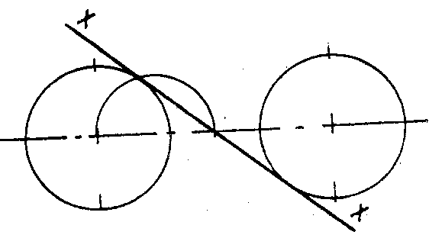

2. Which of the following equations is **correct** about the figure below? A. Rc+ Rx  = Rz

B. Rp + Ry = RzC. Rp + Ry = RcD. Rz– Ry= Rc

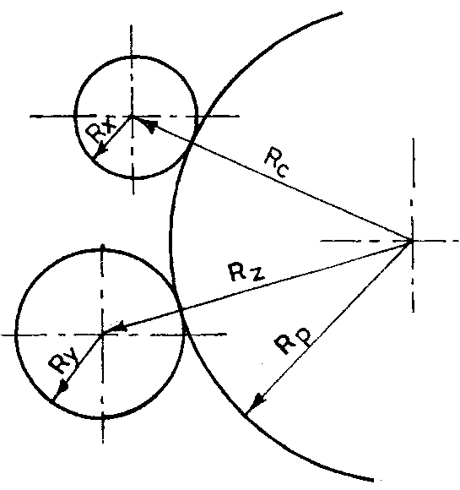

3. What are the lengths of PO and QO respectively in the diagram below? A. 105 and 102 B. 65 and

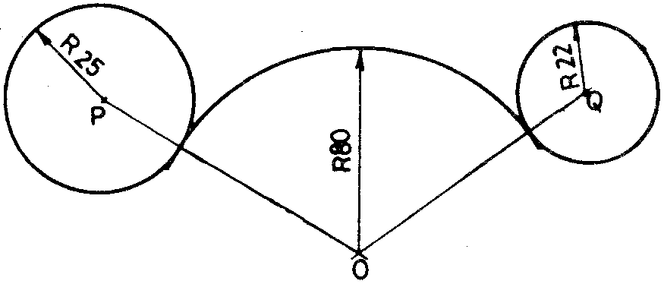

62C. 130 and 124 D. 57 and 55.

4. What type of tangency does the given arc of radius 80 in question 3 above make with the two circles?

A. External. B. Internal. C. Vertical. D. Horizontal.



5. The figure shown above is the construction of a common A. external tangent. B. internal tangent.

C. bisector. D. normal.

**Theory**

1. Construct full size, the template shown below, showing clearly the (i) centres of the arcs;

(ii) points of tangency.

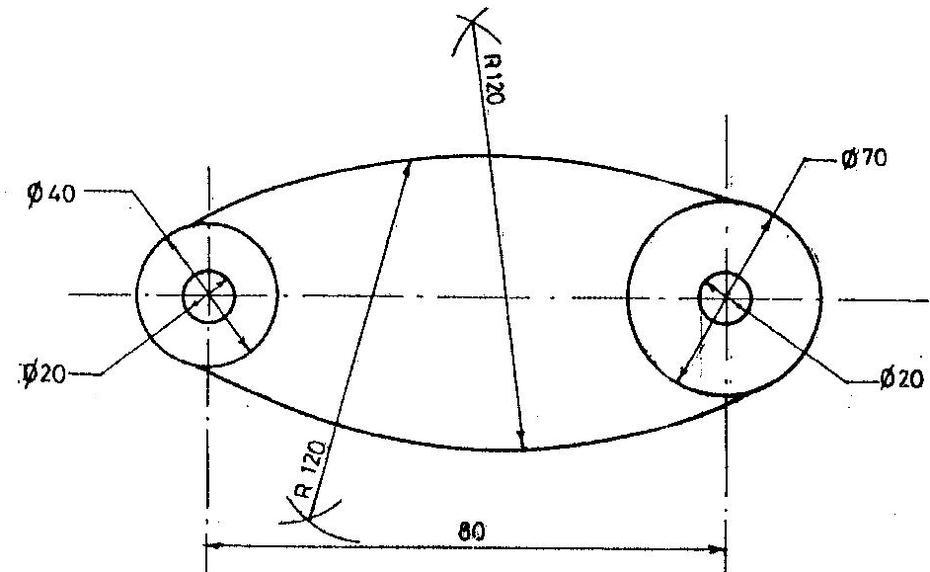

2. Construct full size, the spanner shown below, showing clearly the (i) centres of the arcs; (ii) points



of tangency.

**Further evaluation questions**

Draw full size, each of the tangency problems shown below, showing centres and points of tangency.

